

dbms

Lab # 10



**May 25, 2023**

**muhammad noman**

**35152 - cs**

Query # 01: select ename , sal , grade from emp , salgrade

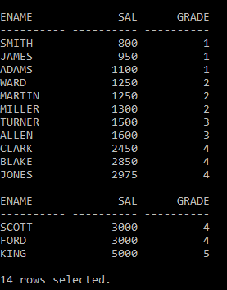 2 where emp.sal between losal and hisal;

Query # 02: select e.ename , s.ename from emp e , emp s

2 where e.mgr = s.empno;

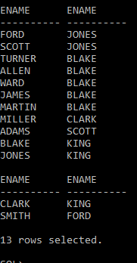

Query # 03: select e.ename , s.ename from emp e , emp s

2 where e.mgr = s.empno

3 order by s.ename;

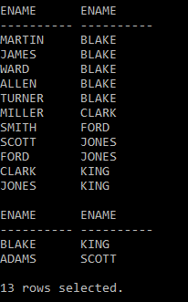

Query # 04: insert into emp (empno , ename , sal) values(32,'Nomi',3000);

Query # 05: insert into emp (empno , ename , sal) values(33,'Hamza',2500);

Query # 06: insert into emp (empno , ename , sal) values(34,'Akhtar',3500);

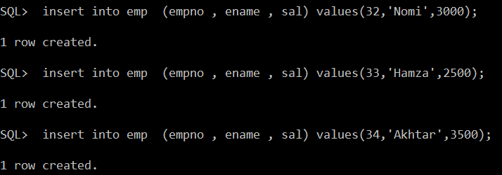

Query # 07: insert into dept (deptno , dname) values(11,'Akhtar');

Query # 08: insert into dept (deptno , dname) values(12,'Haris');

Query # 09: insert into dept (deptno , dname) values(13,'Ali');

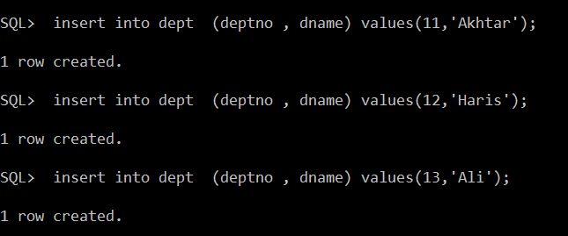

Query # 10: select ename, dname from emp , dept

2 where emp.deptno = dept.deptno;

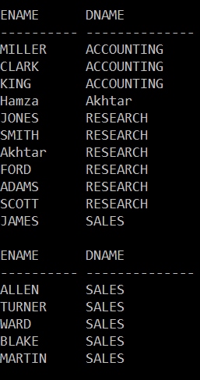

Query # 11: select ename, dname from emp , dept

2 where emp.deptno(+) = dept.deptno

3 union

4 select ename, dname from emp , dept

5 where emp.deptno(+) = dept.deptno;

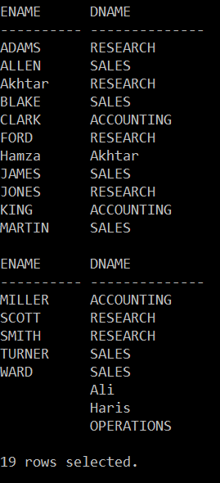

Query # 12: